Министерство Образования и Науки РД
МКОУ «Чинарская СОШ №1»
Открытый урок

на тему:

«Живые существа вокруг нас.
Present Perfect Progressive tense»
в 7 классе

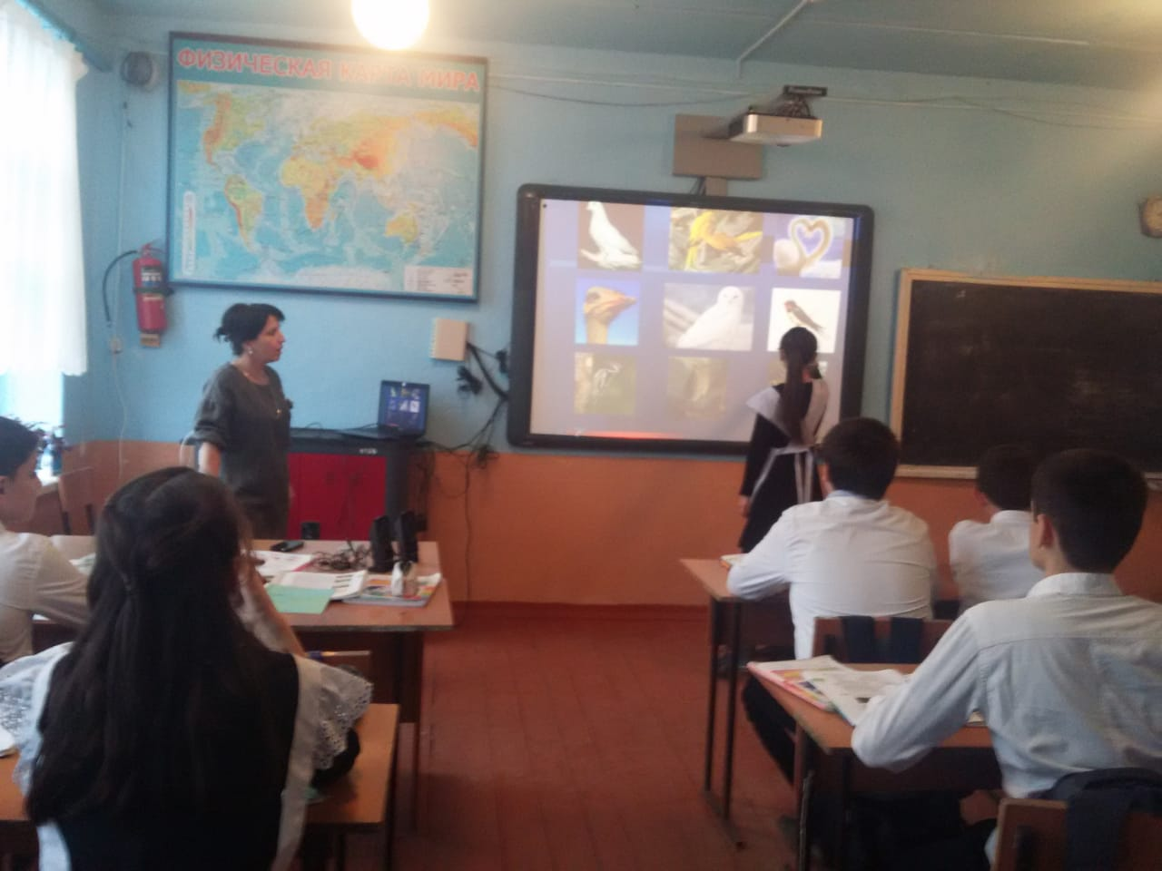

Провела учитель английского языка
Абдурашидова Нармият Шахбановна

2018-2019учеб год.

План-конспект
урока английского языка
в 7 классе
на тему:
Живые существа вокруг нас.
Цель: практиковать лексические знания по теме «Животные и птицы. Живые существа вокруг нас».
Задачи урока:
Обучающие:
Закрепить грамматические навыки по теме Present Perfect Progressive.
Совершенствовать навыки устной монологической и диалогической речи.
Активизировать навыки аудирования в выборочным пониманием услышанного.
Развивающие:
Развивать способности к анализу, сравнению, умение делать выводы по каждому проблемному вопросу и по теме.
Развивать личность ребенка через развитие его способности к самооценке.
Воспитательные:
Воспитывать уважительное, бережливое отношение к природе; формировать желание помочь живым существам вокруг нас.
Тип урока: урок обобщения и систематизации знаний учащихся
Оборудование:
Ноутбук, аудиоприложение к учебнику; листочки А4 и карандаши.
Форма и виды работы: Индивидуальная, фронтальная, парная, групповая.

Ход урока.

Организационный момент.
Приветствие детей.
- Good morning, boys and girls. Glad to see you. Take your seats, please. Today we have an unusual lesson. We have a lot of guests, but don’t be afraid. They are all very nice people.

Постановка целей и задач урока. Мотивация учебной деятельностиучащихся.
- Выявление темы, сообщение целей и задач урока.
We live in the world that is full of the beauty of nature. And animals and birds are the part of that natural world. How do you think what we are going to speak about today?
(Pupils’ answers)
The theme of our lesson today is “Living things around us”.
Read the following statement, please. Think a little and tell me how you understand the statement.
The more we study the Natural World,
the more we study ourselves.

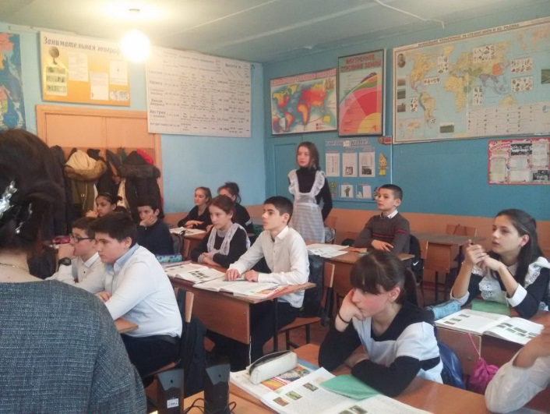
Проверка домашнего задания .
The plan:
1. What is your favouritе animal?
2. Why did you choose it as your favourite?
3. Where does it live?
4. Is it a domestic or a wild animal?
5. Does it jump, run, swim or fly?
6. How long does it live?
7. What does it eat?
8. When does it sleep?
(Дети задают друг другу вопросы о любимых животных с целью проверки домашнего задания).
-Now I’ll describe my favourite animal. Guess which animal is my favourite? (We usually keep it as a pet. It is fluffy and very kind. It likes milk and mice.
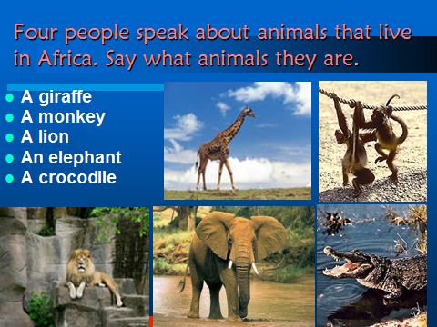
Аудирование .
упр 1 стр 12 . Four people speak about the
animals that live in Africa.
Say what animals they means.

Актуализация знаний.
- Фонетическая зарядка
Let’s revise the names of birds and animals we’ve learnt at our previous lessons. Look at the book and try to guess the birds, plants or animals illustrated there. Pronounce it correctly and say what you know about them.
A sparrow, a swan, a seagull, a parrot, an owl, an ostrich, a woodpecker, a nightingale, a giraffe, a tiger, a crocodile, a wolf, a monkey, a red rose, a thistle, a daffodil.
As we’ve spoken about some flowers as symbols think a little and tell me which flower would you choose as the symbol of our country? I’ll give you some sheets of paper. Draw it quickly and explain why did you choose it? Work in groups of 3-4 pupils.
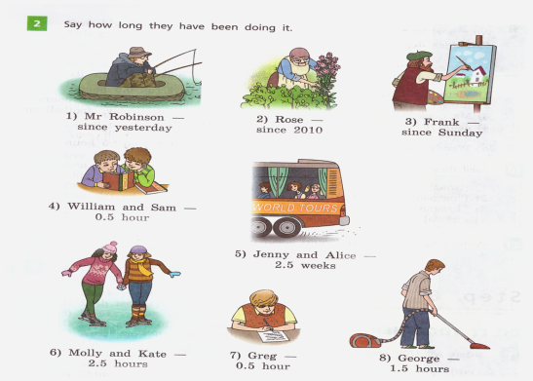
Говорение.
Упр 2 стр 26. Say how long they
have been doing it.

- Развитие навыков чтения
-Now we are going to read to the text .Read it attentively and say what new information you found in it.Choose the right item in the sentences following the text.
Pupils are reading …

Применение знаний и умений в новых ситуациях.
Выполнение упражнений:
- Дискуссия после чтения
-Would you like to live in peace with our Planet? What must we do for it?
-I’d like you to speak about the importance of Zoos. Is keeping animals in Zoos a good idea ?
-What do you know about Zoos in our country?
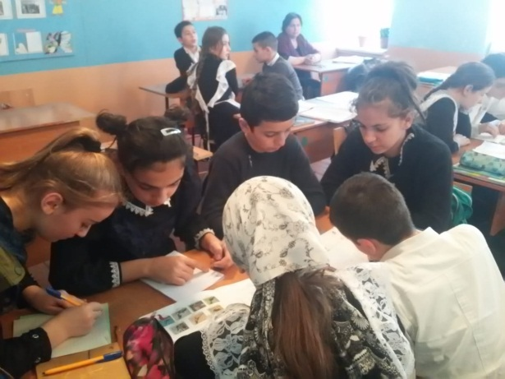
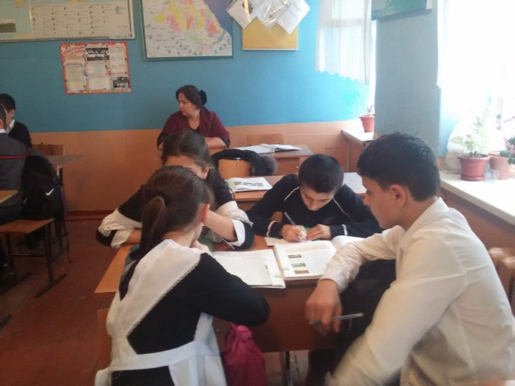

- Актуализация грамматических навыков PRESENT PERFECT PROGRESIVE TENSE.
-I have some situations for you. Please say how long these people have been doing these things. Use the Present Perfect Progressiv Tense
Example:
Tom /to feed homeless dogs/ for 5 years
Tom has been feeding homeless dogs for 5 years.
- My brother /to keep a cat as a pet/for 4 years.
- Marry / to dream about going to our Zoo/for a long time.
- Our class/to help homeless dogs/for 3 months.
- We/to water the trees from our park/ for a year.
- They/not to throw litter in parks and forests/since childhood.
- My classmates / to learn how to protect plants/since last year.

Рефлексия (подведение итогов)
I think that now you know much about living things around us. They play a very important part in our life and it is always interesting to speak about animals and birds that live around.
Did you like the lesson? What did you like most of all? Would you like to take care of animals and birds? Where can we use the information learn at our lesson?
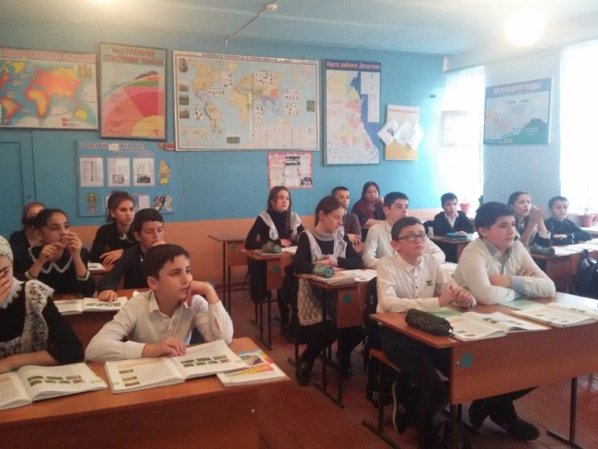
I liked…
I didn’t like…
I’d like some additional information about…
YOUR MARKS ARE…
Homework:
Your homework is to speak about the flora of the place you live. Thank you for your work, my dear friends. You were active, clever and friendly pupils. Good bye.

